FLS/EPC/SP/002/2021 Date: 12-08-2021

To,
Ashish Bansal
Contact:

Sub: - Quotation for Supply, Installation, Testing and Commissioning (SITC) of 3kWp Rooftop mounted Off-grid solar PV power plant.

With reference to the above subject we are pleased to share our techno-commercial proposal for solar roof top mounted power plant project at proposed site on Shri Ashish Bansal’s office. As per the site detail provided, Tinshed rooftop solar power plant of 3kWp (max) is thus proposed.

With more than 8MW+ of successful power projects installation under the belt, we are one of the most progressing EPC company in the field of Solar Power and committed to work as per MNRE/SECI terms and guidelines.

Looking forward to hear from you and assuring best of our services!

Thanking you.
Ankesh Mishra
Founder & Owner
Flasys Smart Solutions
11/12, Water Works Colony,
Hathras, Uttar Pradesh, 204101
Email: contact@flasysdesign.com | Contact: +91 7011558555 | www.flasysdesign.com

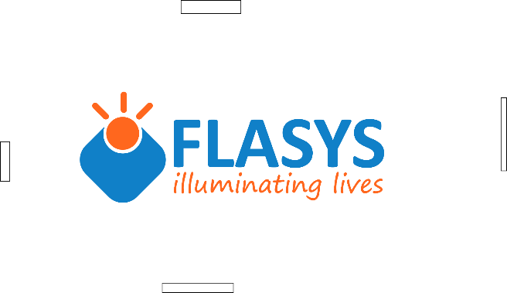
INDEX
S.No. | DESCRIPTION | Pg. No.
1. | About the company | 3
2. | Technical Details | 5
3. | Bill of Material | 6
4. | Area Requirement | 7
5. | Scope of Work | 7
6. | Commercial Proposal | 8




ABOUT US:
FLASYS SMART SOLUTIONS is a registered firm under MSME with registered trademark as ‘FLASYS’ under government of India pioneer in providing comprehensive business solutions for:
- Solar Power Plants (On/Off grid)
- Solar Water Heater
- Solar Water Pumps
- Home Lighting System
- Design & Development Service
- Site Survey and Quality check of solar power Plants
We have done so many projects of kW and MW capacity PAN India they are residential and commercial projects termination of supply on LT and HT both. Our team has an experience of working on almost all kind of rooftops, from RCC rooftops to corrugated sheet metal roofs and ground mounted systems as well. Engineering and designing team perform all kind of shadow analysis, wind and dead load calculations, along with structural design, before commencing the work.
We have high rated expertise in Designing and Development of Solar energy, Electrical planning and simulation across the globe we have done hundreds of designing of US, Singapore, Europe and India based companies. Our installation and commissioning of solar project is long lasting we focus on quality and technicality, we take care of plant by estimating future challenges under the guidance of Expert.

Major Projects Executed:-

S.No. | DESCRIPTION | CAPACITY | LOCATION
1 | Delhi Metro Rail Corporation (Rooftop: RCC and Tinshed) | 4 MWp | Delhi
2 | Bharat Petroleum Corporation Limited (Rooftop and Ground) | 4.2 MWp | PAN India
3 | Indian Statistical Institute Rooftop Solar PV Project | 250 kWp | Delhi
4 | Indian Oil Corporation Limited, | 400 kWp | Bihar
5 | The Akshaya Patra Foundation | 100 kWp | Vrindavan
5 | Solar Rooftop Project, Punjab | 950 kWp | Punjab
6 | Solar water Pump Project, near Haveli Village | 128 HP | Punjab

TECHNICAL DETAILS:
Solar energy is important for many reasons and has great positive impact on environment. Solar / Photovoltaic devices convert light from sun into usable form of electrical energy. These mainly consists of PV modules, module mounting structures, inverters, batteries, monitoring devices etc. The system is further classified as Grid Connect (where the energy from PV system is fed into the Utility Grid) and Off-grid (where the energy generated by the PV system is stored and used when required) and Hybrid (where multiple sources are used for generation of power including conventional sources and utility). The proposed system is an Off-Grid Battery Connect. As the name suggest, Solar Grid Interactive solutions work in tandem with grid electricity, or in some cases in reference with another constant electrical energy source like diesel generators. The systems are designed to reduce energy consumption from the DISCOM, and hence directly help in reducing the Energy bills. Below is the block diagram of Hybrid Off-Grid System.
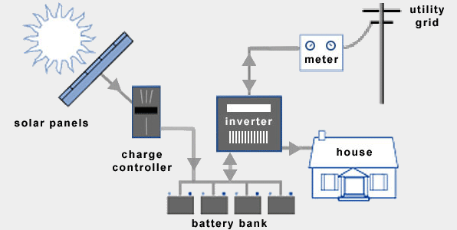

Typical grid connected SPV system
Solar Power Projects’ salient features
- No recurring fuel cost Clean, silent and no moving parts
- Reliable and low maintenance reduction in greenhouse gas emission
- Can be installed at the point of use to prevent transmission line losses.
- Solar panels have life in excess of 25 years and can withstand high winds/ severe hails
Bill of Material
S. No. | Description | Proposed Make | Qty.
1 | SPV Modules | Waaree/ Vikram / Any other MNRE  Approved | As per  Requirement/Design
2 | Module Mounting Structure of Aluminium or MS with Galvanized Iron Mild Steel 80 micron thickness, designed for wind load of 150 KMPH. | Reputed make | As per Requirement/Design
3 | Inverters kW string  Inverters/PCUs 4kW or suitable model with remote monitoring | Sungrow/Solis/Delta/Reputed make | As per Requirement/Design
4 | Battery, 150Ah | Hensel/JMV/reputed make | As per Requirement/Design
5 | PVC insulated UV protected DC Copper cable | KEI/Polycab/MNRE approved | As per Requirement/Design
6 | AC Distribution Board IP65 | CRCA powdered coated 14-16 swg | As per Requirement/Design
7 | AC LT Power Cables Armoured | KEI/Polycab/MNRE approved | As per Requirement/Design
8 | Earthing set complete with earth rods and chemical material and Lighting arrester. | JMV/True Power/Reputed make | As per Requirement/Design
9 | Accessories like tool, HDPE, flexible conduit, cable ties, insulation tapes, etc. | standard /reputed make | As per Requirement/Design
10 | Design & Engineering of complete plant | Flasys | Not applicable
11 | Installation, Testing &  Commissioning Charges and other field activities like unloading of material | Flasys | Not applicable

Area Requirement:
Shadow free area of around 24-30 Square meters (based on true south orientation), is required for a 3kWp plant.
Scope of Work Scope of Work in this offer includes the following:
- Design & Engineering
- System design : PV Plant Layout diagrams
- Engineering drawings SLD diagrams
- Detailed Bill of Materials & Project Report
- Procurement
- Procurement of raw material, Solar Panels, Inverters, BOS electrical and civil material.
- Ordering Material & follow up for delivery of materials
- Invoice certification
- Civil works
- Erection of Module structure for mounting modules on Roof/Tinshade.
- Preparation of earthing pits
- Erection of foundation in case of Rooftop Solar Power Plant.
- Electrical Works
- Placing and erecting PV modules
- Stringing or wiring of Modules for arrays
- Cabling from modules to DC Distribution box
- Cabling from DC Distribution box to Inverter
- Cabling from Inverter to AC Distribution box
- Earthing connections
- Earthing Tests
- Pre Testing of the plant with grid synchronization
- Commissioning of the plant and final plant checks
- Warranty as per terms and conditions mentioned herein.

Exclusions :
- Feeder / LT panel of appropriate bus bar size for connection of the PV plant to grid will be made available at site and shall be in Client Scope.
- Flasys Smart Solutions will not facilitate Net-Metering liasioning work with the concerned DISCOM. All equipment (bi directional and / or solar/ and or check meters) and testing costs required in Net-Metering will be borne by client.

Commercial Details
Sr. No. | Technical Details | Price (Rs.)
1. | Supply, installation, testing and  commissioning of 3kWp (at Rs  75/Wp) Off-grid Battery connected solar PV Power Plant. | INR 2,25,000/- Inclusive of freight  (INR Two Lakh Twenty Five Thousand only)
2. | GST at 5% | INR 11,250/- Inclusive of freight  (INR Eleven Thousand Two Hundred Fifty only)
3. | Total Amount with GST | INR 2,36,250/- Inclusive of freight  (INR Two lakh Thirty Six Thousand Two Hundred Fifty only)

Warranty :
- 5 years of warranty would be provided on inverter from the date of commissioning.
- PV modules will have a limited performance generation warranty as described by the module manufacturers over a period of 25 Years.
- 2 Years of overall warranty on Solar Power Plant.

